Multilingual Microsite - Content Check List
We suggest that you use this to prepare the content of your Multilingual Microsite and keep it for easy referral.
It is not necessary to complete all the options available here. You decide what information is relevant and what you want to publish. Update this as often as you like.
If you are unsure what content to provide, please refer to the Multilingual Microsites - Configuration Guide & Check List.pdf. This Guide suggests that you use ChatGPT to make proposals regarding keywords and phrases as well as descriptions. If you are interested in using ChatGPT (there is no commitment to use its proposals), then please see Appendix One - Using ChatGPT.
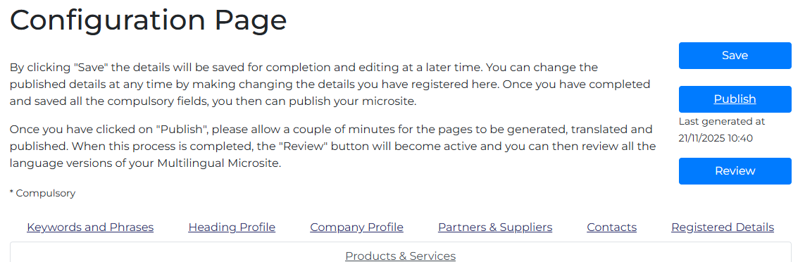

Keywords and Phrases
Keywords and Phrases (maximum 255 characters including spaces)

Heading Profile
Company Name
Link
Logo
Brief description of the company and its activities (max. 750 characters - including spaces). We suggest that you separate these by semicolons. Please also note that these will not be translated.
Brands & Trademarks (max. 150 characters - including spaces). We suggest that you separate these by semicolons. Please also note that these will not be translated.
Link to the About page on your Home Site
YouTube Page
LinkedIn Page
Company Name to be used for the subdomain

Company Profile
Head Office
Street Address 1:
Street Address 2:
City\Town
County\Province\State:
Post Code:
Country
Annual Sales:
Employees:
Industry sectors in which our company is active:
Example 1
Example 2
Example 3
Example 4
Example 5
Our Main Products are:
Example 1
Example 2
Example 3
Example 4
Example 5
Website link listing your products in more detail.
Sales Contact
First name
Last name
Email address

Partners & Suppliers
Industry Organisation 1
Industry Organisation 2
Industry Organisation 3
Industry Organisation 4
Industry Organisation 5
Partners – Industry Sectors
Example 1
Example 2
Example 3
Example 4
Example 5
Geographic Areas
Area 1
Area 2
Area 3
Partnership Contact
First Name
Last Name
Email address
Suppliers - Products
Product 1
Example 2
Example 3
Example 4
Example 5
Supplier Contact
First Name
Last Name
Email Address

Contacts
Main Switchboard Number
Fax
General Email
Website

Registered Details
Certification 1
Certification 2
Certification 3
Certification 4
Certification 5
Lega Form
Date Established
Company Registration Number
VAT Number
Registered Address
Street Address 1
Street Address 2
City / Town:
County\Province\State:
Post Code:
Country:

Products & Services 1
Name
Short Name

Product\Service Name
Trademarks (max. 150 characters - including spaces).
Product\Service Name for Link
Brief product/service description (max. 750 characters - including spaces).
Product/Service keywords and Phrases (maximum 255 characters including spaces)
File 1
File 2
File 3
Link to the product/service profile on the main website:
Link to the price list on Home Website:
Link to product catalogue on Home website:
First Name:
Last Name:
Email Address:

Products & Services 2
Name
Short Name

Product\Service Name
Trademarks (max. 150 characters - including spaces).
Product\Service Name for Link
Brief product/service description (max. 750 characters - including spaces).
Product/Service keywords and Phrases (maximum 255 characters including spaces)
File 1
File 2
File 3
Link to the product/service profile on the main website:
Link to the price list on Home Website:
Link to product catalogue on Home website:
First Name:
Last Name:
Email Address:

Products & Services 3
Name
Short Name

Product\Service Name
Trademarks (max. 150 characters - including spaces).
Product\Service Name for Link
Brief product/service description (max. 750 characters - including spaces).
Product/Service keywords and Phrases (maximum 255 characters including spaces)
File 1
File 2
File 3
Link to the product/service profile on the main website:
Link to the price list on Home Website:
Link to product catalogue on Home website:
First Name:
Last Name:
Email Address:

Products & Services 4
Name
Short Name

Product\Service Name
Trademarks (max. 150 characters - including spaces).
Product\Service Name for Link
Brief product/service description (max. 750 characters - including spaces).
Product/Service keywords and Phrases (maximum 255 characters including spaces)
File 1
File 2
File 3
Link to the product/service profile on the main website:
Link to the price list on Home Website:
Link to product catalogue on Home website:
First Name:
Last Name:
Email Address:

Products & Services 5
Name
Short Name

Product\Service Name
Trademarks (max. 150 characters - including spaces).
Product\Service Name for Link
Brief product/service description (max. 750 characters - including spaces).
Product/Service keywords and Phrases (maximum 255 characters including spaces)
File 1
File 2
File 3
Link to the product/service profile on the main website:
Link to the price list on Home Website:
Link to product catalogue on Home website:
First Name:
Last Name:
Email Address:

Appendix One - Using ChatGPT
You may find it useful to use ChatGPT to generate Keywords and Phrases as well as to draft your description of your company or your individual products and services.
If you do use ChatGPT, then you may find it helpful to use the following instructions for ChatGPT– with suitable edits and additions to fit your situation; this includes adding:
- Keywords and phrases you think are important (optional).
- A description of your company\product\service that you think provides a summary of the main competitive advantages you would like to emphasise. (Optional.)
- The tone that you want to project.
The more information you can provide about your competitors and about yourself and your products and services, the better the suggestions that can be expected from ChatGPT.

Instructions to ChatGPT

First Step – generate keywords and phrases
I would like your help in drafting the keywords and phrases for a multilingual microsite that we are preparing for publication.
Our Home website is (insert web address).
Our main competitors are: (insert company names and web addresses).
Our target markets are (insert). Therefore, our market is (B2C, B2B, B2G).
These keywords and phrases will be translated into 35 languages (using, mainly, Google Translate).
We have space for just 255 characters including spaces. (If a translation exceeds this limit, that is not a problem.)
Our trademarks are (insert) and these are already scheduled to be added as keywords and phrases without impacting the 255 character limit. These will not be translated.)
The 255 character limit is for each language, not a total for all the languages.
Therefore, they should be easily translatable without linguistic or cultural barriers.
Clearly, these keywords and phrases are to improve the microsite’s SEO and should therefore differentiate our company\product\service from that of your competitors.
Our suggestions for these keywords and phrases are (insert), but would welcome your suggestions. (This is optional.)
These keywords and phrases will be used in the description of the company\product\service that I will ask you to draft in a second step.
Second Step – generate description of the company\product\service for the microsite (Once you have agreement on the keywords and phrases.)
Now I need a description to be used in the microsite. In drafting this description, the following considerations should be taken into account:
There is a limit of 750 characters including spaces. (If a translation exceeds this limit, that is not a problem.)
Again, this limit is for each language, not a total for all the languages.
The agreed keywords and phrases should be used wherever possible in the description text to reinforce the microsite’s SEO.
The competitors remain the same.
This text will also be translated into 35 languages (using mainly Google Translate).
Again, it should be easily translatable without linguistic or cultural barriers.
Our market is (B2C, B2B, B2G) and the tone of the text should reflect this.
Our suggestion for the description is (insert), but would welcome your suggestions. (This is optional).

Kenniscentrumbronnen
Aanvullende richtlijnen over exportzichtbaarheid, meertalige digitale aanwezigheid en digitale handelsinfrastructuur zijn beschikbaar in de ExpoWorld Resourcebibliotheek.
De Resourcebibliotheek biedt een overzicht van alle publicaties van het Kenniscentrum, samen met korte beschrijvingen van elk document.
Aanvullende resources worden periodiek toegevoegd. Nieuwe publicaties verschijnen in de Resourcebibliotheek zodra deze beschikbaar zijn.

